DEPARTMENT OF BOTANY

LONG TERM INTERNSHIP
ACADEMIC YEAR (2025-2026)

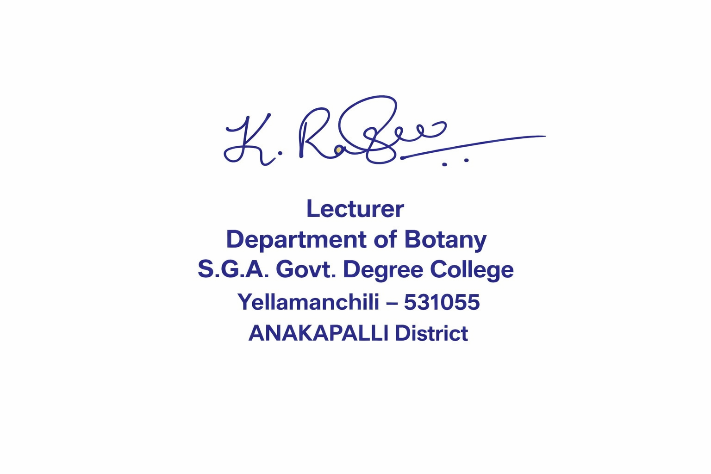
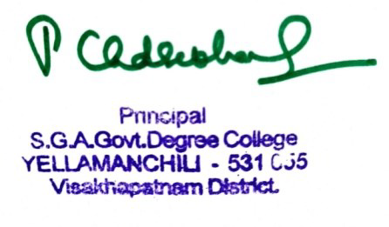

SIGNATURE OF LECTURER SIGNATURE OF PRINCIPAL

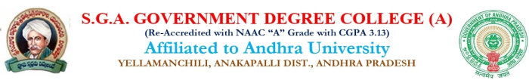
DEPARTMENT OF BOTANY
LONG TERM INTERNSHIP-2025-26
BSC BOTANY (HONS) SEMESTER-VI
(25-Nov-2025)
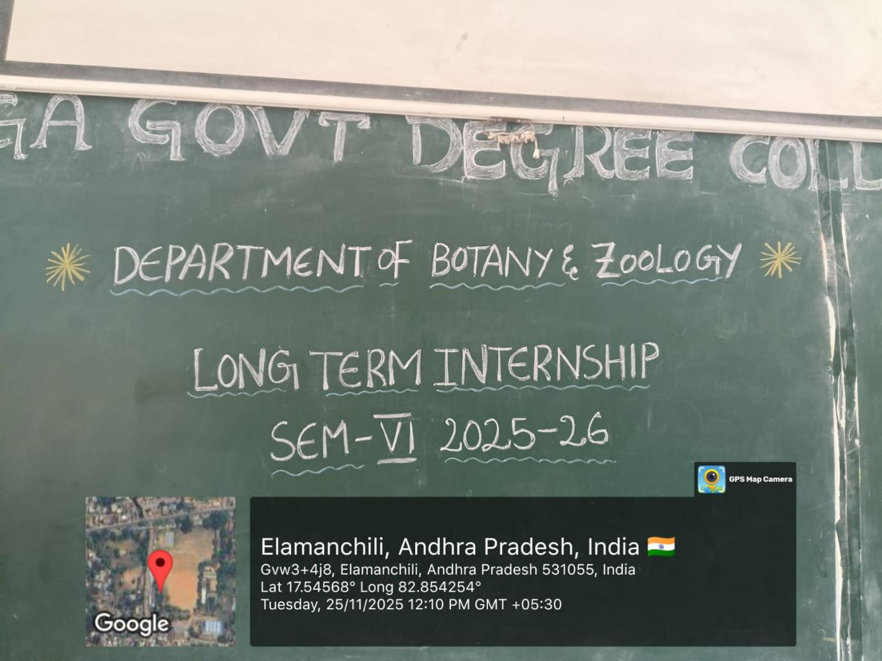

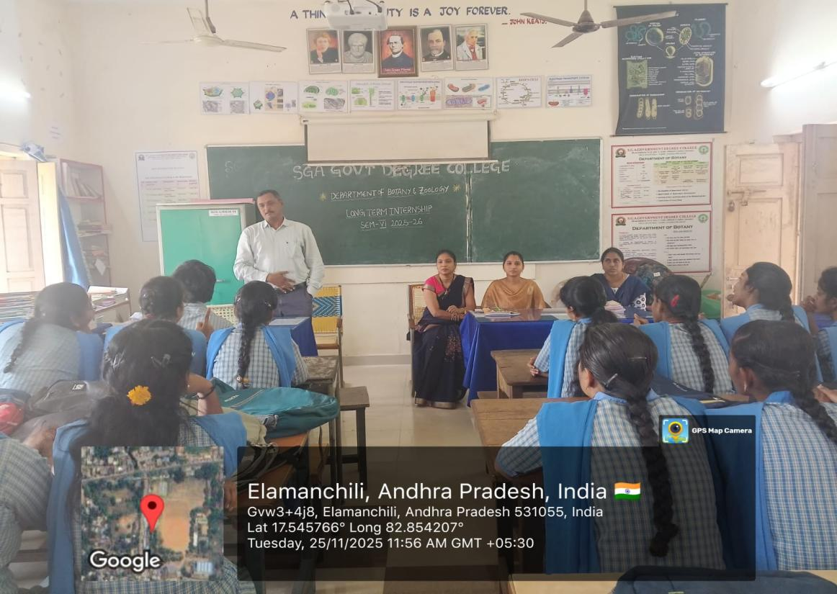

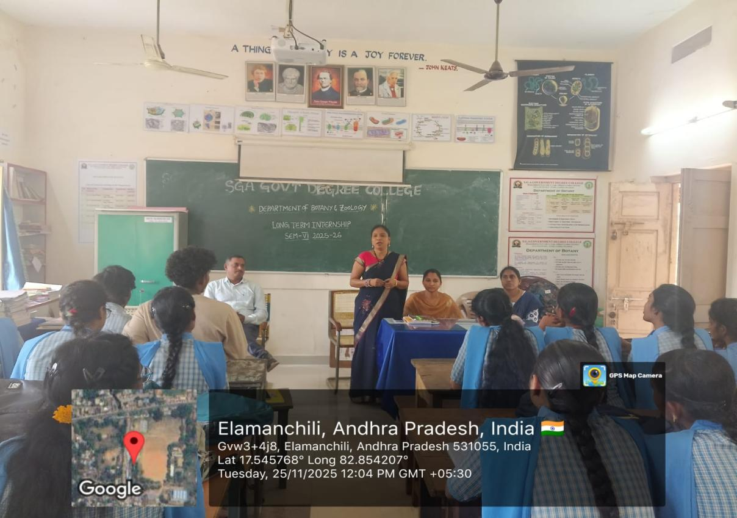

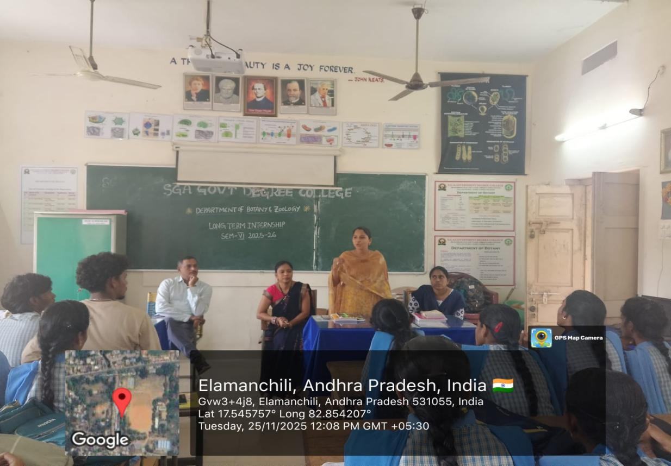

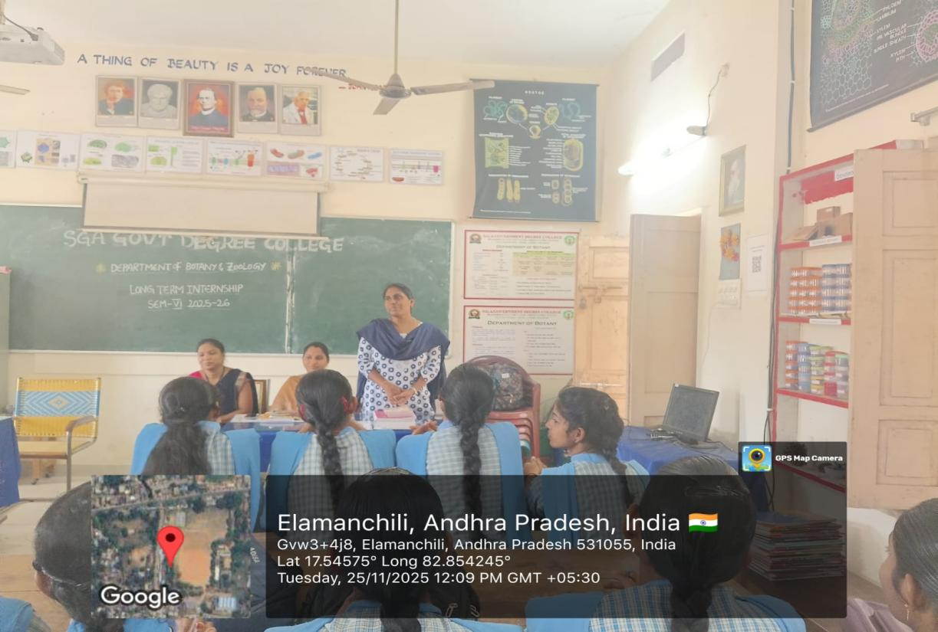
3RD BSC BOTANY STUDENT LIST
SL.NO | NAME | YEAR | GROUP | REGISTER  NUMBER
1. | Gokiveda Leelaveni | III Year | B.Sc Botany (Hons) | 722135405092
2 | Grandhi Lakshmi Prasanna kumari | III Year | B.Sc Botany (Hons) | 722135405095
3 | Addala Divya Prasanthi | III Year | B.Sc Botany (Hons) | 723135405065
4 | Appikonda Kumari | III Year | B.Sc Botany (Hons) | 723135405067
5 | Chukkala Tharuna Durga Satyaveni | III Year | B.Sc Botany (Hons) | 723135405074
6 | Dara Bangaramma | III Year | B.Sc Botany (Hons) | 723135405075
7 | Dugsnaboyina Venkata Lakshmi | III Year | B.Sc Botany (Hons) | 723135405077
8 | Madala Tarangini | III Year | B.Sc Botany (Hons) | 723135405088
9 | Makireddi Rama Thulasi | III Year | B.Sc Botany (Hons) | 723135405090
10 | Malla Deviloka | III Year | B.Sc Botany (Hons) | 723135405091
11 | Manaparthi Renuka | III Year | B.Sc Botany (Hons) | 723135405093
12 | Molli Rupasri | III Year | B.Sc Botany (Hons) | 723135405096
13 | Pandula Pavithra | III Year | B.Sc Botany (Hons) | 723135405100
14 | Rayi Hema | III Year | B.Sc Botany (Hons) | 723135405103
15 | Silaparasetti Manasa | III Year | B.Sc Botany (Hons) | 723135405104
16 | Yellamanchili Bhargavi | III Year | B.Sc Botany (Hons) | 723135405115
17 | Yellisetty Meghana | III Year | B.Sc Botany (Hons) | 723135405116

